Matrices

The term matrix (plural matrices) refers to a rectangular table or array of elements which we interpret in useful ways, and for which mathematicians have defined useful operations or manipulations. Often in computer graphics applications, the elements of matrices will eventually be numbers, but they may start out as formulas or other mathematical objects. To some extent, a matrix can be viewed as the mathematical counterpart of a two-subscript array in computer programming, and one convenient (though not necessarily efficient) way of implementing matrix operations in a computer program is via two-subscript arrays.

There has been a very extensive and rich theory developed for matrices and the many useful operations that have been defined for them. In this document, we’ll present only those basic definitions, and describe the basic operations which are most useful in describing or formulating methods of manipulating graphical images.

In these notes, matrices will usually be denoted by boldface upper case characters. An m × n matrix is a matrix with m rows and n columns ⎯ these are called the dimensions or shape of the matrix. Elements within a matrix are distinguished using a two-subscript notation. Thus, the third element in the second row of matrix A will be indicated as A₂₃ (the first subscript gives the row number and the second subscript gives the column number). In general, the symbol A_{kj} would denote the element in the k^{th} row and the j^{th} column. Usually in mathematical work, row and column numbering begins with 1 rather than 0.

Example:
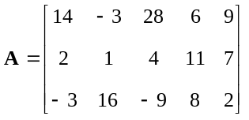

is a 3 × 5 matrix, and
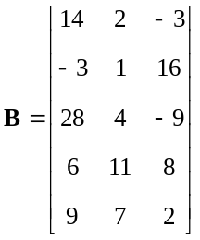

is a 5 × 3 matrix. Despite the fact that A and B contain the same 15 values, they are quite distinct and un-equivalent matrices because of their different shape. Usually matrices are “rendered” using square brackets as above.

As an illustration of the subscript notation for individual elements of a matrix, we note that here

A₂₅ = 7

(since the fifth element in the second row of A is 7). Similarly

B₅₂ = 7

(since the second element of the fifth row of B is 7). It would make no sense to ask for A₅₂ here, because this would indicate the second element of the nonexistent fifth row of A.
The first elements of the first rows of the two matrices here are indicated by subscripts 11; that is:
A₁₁ = 14 and B₁₁ = 14.
uuu

Some additional terminology you will encounter is:

- a matrix with all elements equal to zero is called a zero matrix.
- a square matrix is one where the number of rows is the same as the number of columns.
- those elements of a square matrix which have identical row and column indices (A₁₁, A₂₂, A₃₃, and so on) are said to form the main diagonal of the matrix.
- A square matrix in which all elements on the main diagonal are 1 and all other elements are zero, is called an identity matrix. Identity matrices are often denoted by a boldface I (upper case character “eye”) or a boldface 1 (number “one”). Identity matrices play the same role in the multiplication of matrices as the simple number 1 plays in the multiplication of numbers.

Example:
I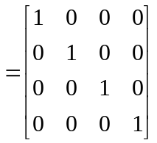 (MAT-1)

is a 4 × 4 identity matrix. It is square because the number of rows (4) is equal to the number of columns (4). All elements are zeros except for the 1’s located on the main diagonal of the matrix:

I₁₁ = 1, I₂₂ = 1, I₃₃ = 1, I₄₄ = 1.
uuu

Note that vectors can be considered to be matrices with either one row or one column, depending on how you write out the components. If the components of the vector are written in a row:
a 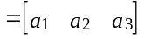

that is, as a row vector, it is natural to also consider a as forming a 1 × 3 matrix. If the components are written as a column vector:
a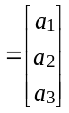
it is natural to consider a as forming a 3 × 1 matrix in this case.

Addition or Subtraction of Matrices

The sum or difference of two matrices is defined only if they have the same shape. In that case, the sum or difference is just done elementwise:

(A + B)_{kj} = A_{kj} + B_{kj}

(A - B)_{kj} = A_{kj} - B_{kj}

Example:
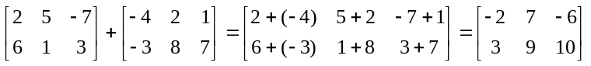
uuu

Addition and subtraction of matrices are important operations in computer graphics when the matrices involved are row or column vectors, but generally, is not as important for other types of matrices that arise in computer graphics.

Matrix Multiplication

The product of two matrices is defined only if they conform in shape. The left factor must have the same number of columns as there are rows in the right factor. Otherwise, the product is not defined. In symbols
(MAT-2)
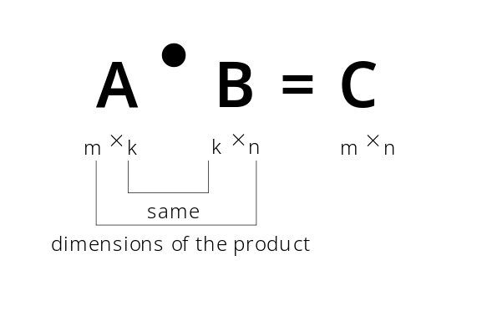

You see that the number of rows in the result is the same as the number of rows in the left factor. The number of columns in the product is equal to the number of columns in the right factor. The formula for the (i, j) element of the product, C, is

C_{ij} = A_{i1}B_{1j} + A_{i2}B_{2j} + A_{i3}B_{3j} + … + A_{ik}B_{kj} = 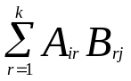 | (MAT-3)

To get the (i, j) element of the product, you multiply the elements of the i^{th} row of A by the corresponding elements of the j^{th} column of B and add up the resulting products:

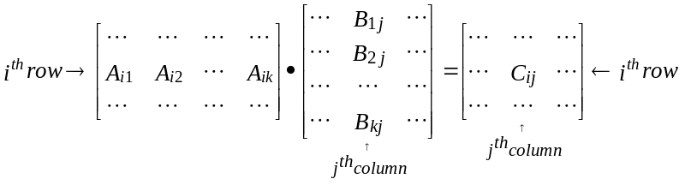

In forming the product AB to get C, we say that A premultiplies B or “A multiplies B from the left.” Similarly, we say that B postmultiplies A or “B multiplies A from the right.”

Example:
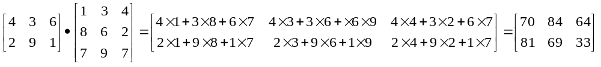
Here we’ve multiplied a 2 × 3 matrix onto a 3 × 3 matrix to get as a result a 2 × 3 matrix.
uuu

You can see why the number of columns in the left factor matrix must be equal to the number of rows in the right factor matrix. Otherwise, when the products of elements of the i^{th} row of the left factor with the elements of the j^{th} column of the right factor are formed, some elements of one factor would not have elements of the other to be multiplied with.

This may appear to be a very weird way to do multiplication. Perhaps, but set up in this way, matrix multiplication becomes one of the most powerful and useful operations in manipulating graphical images.

Obviously, finding the product of two or more matrices by hand can be a very tedious job. Most computer spreadsheet applications have a built-in matrix multiplication procedure (for example, the function MMULT() in Excel), and it is not difficult at all to write code in C, Pascal, BASIC and similar programming languages to carry out matrix multiplications. One would rarely actually do matrix multiplication by hand except to learn the procedure or when doing very small scale experimental calculations.

Three properties of matrix multiplication that you need to keep in mind (because they have implications or applications in our use of matrix multiplication in manipulating graphical images) are:

- Matrix multiplication is associative. This means that to calculate the product of three matrices, say, ABC, you can first multiply A and B to get the product AB and then multiply this intermediate product by C from the right to get the product of the three matrices, or, you can first multiply B and C to get the intermediate product BC and then multiply this intermediate product by A from the left to get the product of the three matrices. The result will be the same with either procedure. In symbols, we can say that

(AB)C ≡ A(BC) | (MAT-4)

Products of more than three matrices are evaluated by successive pairwise multiplications. The sequence in which the pairwise multiplications are done doesn’t matter as long as the order of factors is not changed.

- Matrix multiplication is distributive with respect to addition/subtraction. In symbols, this means that

(A + B)•C ≡ A•C + B•C  A•(B + C) ≡ A•B + A•C | (MAT-5)

- However, matrix multiplication is not commutative. The order of the factors in a matrix product cannot be changed without changing the result (in fact, if non-square matrices are involved, changing the order of the factors may even mean multiplication no longer makes sense because in the new order the matrices do not conform for multiplication). In symbols,

A•B ≠ B•A | (MAT-6)

Even when both A•B and B•A are well-defined matrix products, reversing the order of multiplication like this will yield the same result only in special cases or by coincidence.

Example:
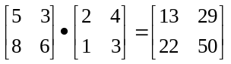
but
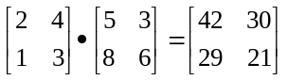

The two results are not at all the same. Note another more extreme example:
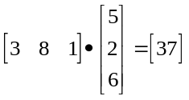,
the product of a 1 × 3 matrix onto a 3 × 1 matrix being a 1 × 1 matrix. However, reversing these two factors gives the product of a 3 × 1 matrix onto a 1 × 3 matrix, producing a result which is a 3 × 3 matrix:
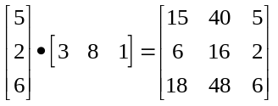
uuu

The Identity Matrix

Notice what happens when we multiply an m × n matrix A onto an n × n identity matrix from the left:
A•I = C

Then
C_{ij} = A_{i1}I_{1j} + A_{i2}I_{2j} + … A_{in}I_{nj}

All of the terms on the right-hand side of this equation will be zero except the one in which the two indices of I match (since all elements of I are zeros except those on the main diagonal, which are 1). Thus,

C_{ij} = 0 + 0 + … + A_{ij}I_{jj} + 0 + … + 0 = A_{ij}

Thus, C and A here are the same matrices, since they have the same elements. From this, we conclude that

A•I = A | (MAT-7a)

That is, multiplying a matrix by a conforming identity matrix from the right just gives you back the original matrix. The same thing will happen if we multiply A from the left by a conforming identity matrix:

I•A = A | (MAT-7b)

In this way, identity matrices play the same role in matrix multiplication that the number 1 plays in ordinary arithmetic.

Transpose of a Matrix

Transposing a matrix involves swapping its rows and columns. A common notation is to write A^{T} for the transpose of A.

Example:
If
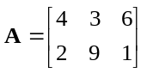
then
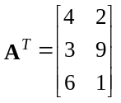
That is, row 1 of matrix A becomes column 1 of matrix A^{T}, row 2 of matrix A becomes column 2 of matrix A^{T}, and so forth.
uuu
You can see that in general
(A^{T})_{ij} = A_{ji} | (MAT-8)

and if A is an n × m matrix, then A^{T} will be an m × n matrix.

Dividing By a Matrix
Our ability to multiply two matrices together is exploited in developing a useful operation which is the equivalent of division by a matrix.

In ordinary arithmetic with numbers, we can think of division as multiplication by a reciprocal. Thus,
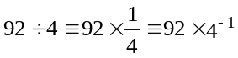
to use a common exponential notation in the last form. Of course, we know the numerical value that 4⁻¹ stands for here, and we can easily come up with its numerical equivalent (4⁻¹ = 0.25). Nevertheless, even though we can consider “division by 4” to be equivalent to “multiplication by this thing 4⁻¹”, to be a useful alternative to the operation of division, we need to be able to define (and hopefully find a way to compute) 4⁻¹ in terms of arithmetic operations that do not involve the operation of division. But this is easily done, since we can define 4⁻¹ to be the value which satisfies

4•4⁻¹ = 1 or 4⁻¹•4 = 1

In the same way, we will define division by a matrix A to be equivalent to multiplication by its inverse matrix A⁻¹. In general, we need to specify from which side the multiplication is occurring (because matrix multiplication is not commutative), and so it is necessary to distinguish between left inverses A_{L}⁻¹ (satisfying A_{L}⁻¹•A = 1), and right inverses A_{R}⁻¹ (satisfying A•A_{R}⁻¹ = 1). However, it turns out that if we consider only square matrices, and if either one of A_{L}⁻¹ or A_{R}⁻¹ can be found, then the other one exists and is identical ⎯ that is, when square matrices have an inverse, the left and right inverses are identical, and this common inverse matrix is called the inverse, A⁻¹, of A:

A•A⁻¹ = 1, A⁻¹•A = 1 | (MAT-9)

If A is an n × n matrix, then A⁻¹ must also be an n × n matrix ⎯ the inverse of a square matrix is a square matrix of the same size.

Just as not every number has a reciprocal in ordinary arithmetic (for example, 0⁻¹ = 1/0 is not defined), so there are square matrices which do not have inverses. Such matrices are said to be singular. Although singular matrices do arise in computer graphic applications, we know why this occurs and know better than to try to determine their inverses.

How can we determine what the matrix A⁻¹ is? The easiest approach is to get someone else to do it for you! The function MINVERSE() in Excel will do the job, and algorithms to calculate elements of matrix inverses coded in all major programming languages are readily available. Consult a book on linear algebra or numerical analysis for further details.

The primary role played by matrix multiplication in computer graphics is in representing geometric transformations of images (moving, scaling, rotating, reflecting images). When a matrix represents a particular geometric transformation of an image, its inverse will represent the opposite (or ‘undo’) transformation. Thus, if a matrix represents a rotation of the image by 30º counterclockwise, then its inverse will represent a rotation of the image by 30º clockwise (or -30º counterclockwise). In this case, knowledge of how to construct a rotation transformation will enable us to write down both the original rotation matrix as well as its inverse without further computation. This matter is described and illustrated more completely in the notes on transformations.

As mentioned, details of methods for calculating elements of matrix inverses are given in books on linear algebra and on numerical methods. Generally, they consist of algorithms rather than direct formulas, because for matrices much bigger than 2 × 2, the direct formulas become impractically complicated. In the case of a 2 × 2 matrix, we have:
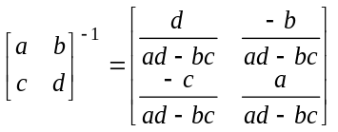

Determinants

Associated with every square matrix A is a single numerical quantity called its determinant, denoted either as det A or drawn as a matrix, but with single vertical lines replacing the square brackets. In general, the computation of determinants is quite a complicated thing and may be achieved using existing software (the function MDETERM() in Excel is an example, and algorithms coded in all major programming languages are readily available). However, there are relatively simple procedures that work for determinants of 2 × 2 and 3 × 3 matrices, and these arise often enough in computer graphics that it is worth describing them.

For a 2 × 2 matrix
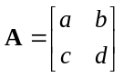
we get

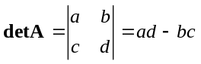 | (MAT-10)

That is, subtract the product of the off-diagonal elements from the product of the diagonal elements.

Example:
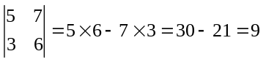
uuu

For a 3 × 3 matrix,
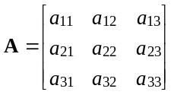
the calculation of det A can be organized by writing down the three columns of the matrix, and then repeating the first two columns again to give the five-column array:

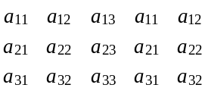
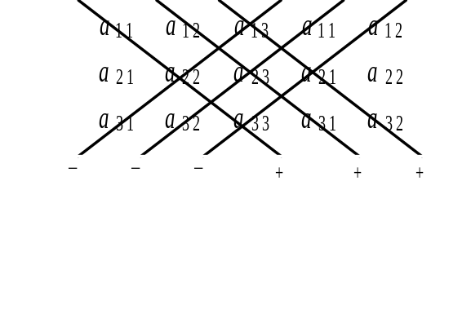
Now it is possible to identify three diagonals oriented downwards to the right and three diagonals downwards to the left as shown in the diagram to the right. The value of det A is obtained by adding up the products of the numbers on the downward- rightwards diagonals, and subtracting from this the products of the numbers on each of the downward-leftwards diagonals. The result will be the desired value of the determinant.

Example:
For
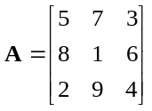
we get
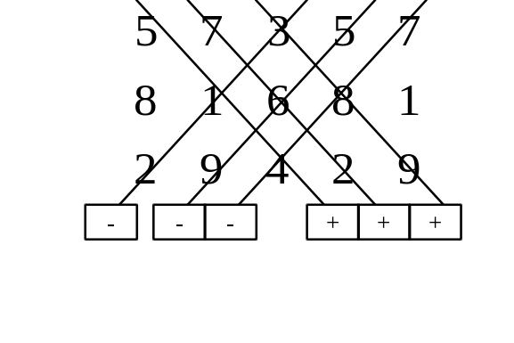

= 5 × 1 × 4 + 7 × 6 × 2 + 3 × 8 × 9
3 × 1 × 2 - 5 × 6 × 9
- 7 × 8 × 4

= -130.

Thus, here,
det A = -130.
uuu

Determinants will arise in a number of applications in computer graphics. The evaluation of a 3 × 3 determinant is involved in calculating vector cross products (used to determine directions perpendicular to a planar surface being modelled) for example. Singular matrices have determinants equal to zero.

Systems of Linear Equations

An example of a system of linear equations is:

5x - 3y + 4z = 33
4x + 2y - z = 1
3x + 5y + 6z = 31

The equations are linear because only the first power of each unknown appears. This is a system of equations, because the goal is to get a single set of values for (x, y, z) that satisfies all three equations at once. In general, for this goal to be met, you need to have the same number of equations as unknowns (though even then you aren’t assured that the system has a solution).

We can write this system of equations more compactly by first defining some matrices:
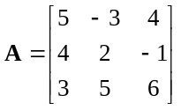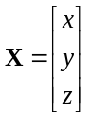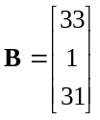

Here A is the matrix with elements made up of the coefficients of the unknowns from the left-hand-sides of the equations, X is a column matrix made up of the unknowns themselves, and B is a column matrix containing the right-hand-sides of the system of equations. With these definitions, the system of equations can be abbreviated as a matrix equation:

A•X = B | (MAT-11)

Further, it is now possible to write a simple formula for the solution. Just multiply from the left by A⁻¹, the inverse of A to get

A⁻¹AX = A⁻¹B

But, since A⁻¹A on the left is just an identity matrix, 1, and 1•X = 1, this last simplifies to

X = A⁻¹B | (MAT-12)

Although this may not be the most direct way to obtain a solution of a system of linear equations in all situations, it does demonstrate that the solution of such a system can always be obtained in principle by multiplying the column matrix of the right-hand-sides of the system of equations from the left by the inverse of the matrix of coefficients.

(Notice that this is analogous to solving the simple algebraic equation, say,
5x = 30
by multiplying both sides by 1/5:
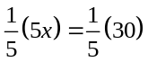
or
x = 6. )

Situations arise in computer graphics applications where solutions of systems of a small number of simultaneous linear equations must be obtained. For a system of two equations in two unknowns, the easiest approach is simply to use the following formulas. Writing

ax + by = c  dx + ey = f | (MAT-13a)

the solution is given by
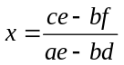, 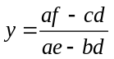 | (MAT-13b)

Example:
Solve
5s - 7t = -73
2s + 3t = 23
for s and t.

Solution:
Compare (MAT-13a) with this system of two equations. Here s replaces x and t replaces y. Then, by comparison, we get

a = 5, b = -7, c = -73, d = 2, e = 3, and f = 23.

Plugging these values into (MAT-13b) gives:
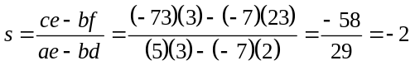
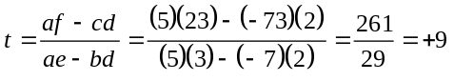
You can easily verify by substituting s = -2, t = 9 into the original equations that these values satisfy both systems.
uuu

If formulas (MAT-13b) seem to have a pattern to them, it’s because the right-hand sides of the two formulas are really the ratio of the expansions of two 2 × 2 determinants:
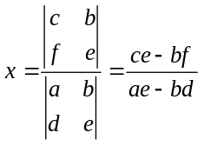; 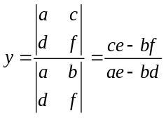
Here, the denominators are the same in both cases, being the determinant of the matrix of coefficients of the left-hand sides of the two equations. The numerators are determinants of matrices which start out as the matrix of coefficients on the left-hand side of the system of equations, but have the column corresponding to the unknown replaced by the right-hand sides of the equations. This is the simplest case of Cramer’s Rule for solving systems of linear equations, and works for systems of any number of equations. However, it is most useful for systems of 2 or at most 3 equations, since determinants become quite difficult to calculate by hand once they have more than 3 rows and columns.

Similar direct formulas for the solution of three simultaneous linear equations in three unknowns are too complicated to be generally useful. Instead, we will simply illustrate a procedure for solving systems of equations which is feasible for the manual solution of systems of three equations. This is the so-called elimination method.

Example:
Solve the system of equations:

5x - 3y + 4z = 33 (eq. 1)
4x + 2y - z = 1 (eq. 2)
3x + 5y + 6z = 31 (eq. 3)

Solution:
We’ve numbered the equations for convenience of reference.

The elimination method consists of two major steps, each of which may involve a number of sub-steps. First, we use the first equation to eliminate all terms involving x from the remaining equations (in this case, the remaining two equations). To do this, proceed as follows here. Write down (eq. 1) multiplied by the negative of the coefficient of x in (eq. 2). Immediately below that, write down the (eq. 2) multiplied by the coefficient of x in (eq. 1). Then add the two new equations together. In this example, we get:

-20x + 12y - 16z = -132 -4 × (eq. 1)
20x + 10y - 5z = 5 5 × (eq. 2)

22y - 21z = -127 (eq. 2a)

Now, do the same thing with (eq. 1) and (eq. 3):

-15x + 9y - 12z = -99 -3 × (eq. 1)
15x + 25y + 30z = 155 5 × (eq. 3)

34y + 18z = 56 (eq. 3a)

Notice that (eq. 2) and (eq. 3) have been replaced by the equivalents (eq. 2a) and (eq. 3a), respectively, which contain no reference to the unknown x. In fact, (eq. 2a) and (eq. 3a) now form a system of two equations in the two unknowns y and z. We could solve for y and z using formulas (MAT-13b).

Instead, we’ll apply this elimination procedure once more, using (eq. 2a) to eliminate y from (eq. 3a):

-748y + 714z = 4318 -34 × (eq. 2a)
748y + 396z = 1232 22 × (eq. 3a)

1110z = 5550 (eq. 3b)

(eq. 3b) now just contains a single unknown, z, and we can solve it immediately:
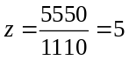
But, if we substitute z = 5 into, say, (eq. 2a) it becomes an equation with just the one unknown y, and so easily solvable:

22y - (21)(5) = -127
or 22y = -127 + (21)(5)
or 22y = -22
giving
y = -1.

Finally, substituting z = 5 and y = -1 into, say, (eq. 1) will leave us with the single unknown x there:

5x - 3(-1) + 4(5) = 33
so 5x = 33 + 3(-1) - 4(5) = 10
giving
x = 10/5 = 2.

You can easily verify by direct substitution that x = 2, y = -1, z = 5 satisfies all three of the original equations.
uuu

Notice that the elimination method uses the first equation of the system to eliminate the first unknown from all of the remaining equations. This leaves you with a new system of linear equations containing one less equation and one less unknown. You then repeat the procedure with this new smaller system of equations, to obtain another system of equations with one further equation less and one further unknown less. This process can be repeated until you obtain the simplest possible system: one equation in one unknown. Solve that equation. Then, when you substitute the solution of that equation into one of the two equations obtained in the next to last elimination step, you get another equation containing just a single unknown, which you can solve. This backsubstitution process is repeated until values for all of the unknowns have been obtained.

Obviously, this procedure becomes unacceptably tedious for hand calculations if more than three or four equations are involved. In such a situation you must find a computer program to do the job.

